Sean Murphy

Z23642875

2/5/2023 2:57PM

Git Hub Username: seanm519 or Sean Murphy

Git Hub Repository: https://github.com/cop4808-spring-2023-fullstack-web/cop4808-git-and-github-fundamentals-seanm519.git

Objective 1: quizzes

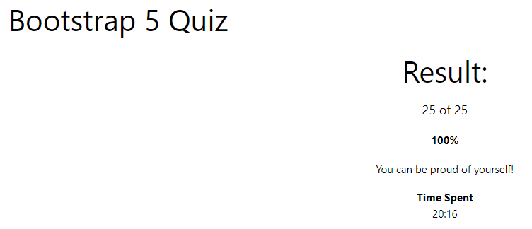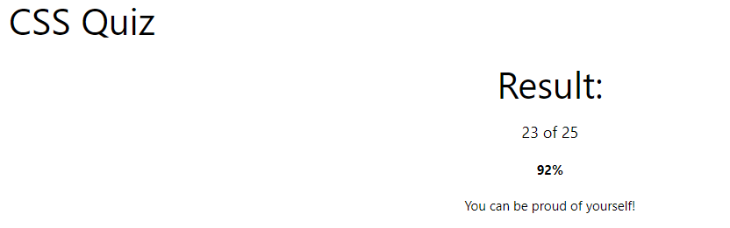

Objective 2: Calculator upgrade

First I added the button for the square root function

Then I added the functionality for the button and repeated this process for the other three buttons: ln, Pi, and Round

Next I added the “other” class to store the color for the new buttons and added that class to the buttons

Lastly I moved the buttons to the top of the list to positions them properly for the hw requirements and I added another row so the buttons were formatted properly. I also added comments within the code.

Screenshot of added row and buttons:

